EXPT NO: 7 | IMPLEMENTATION OF A SIMPLE AUTOENCODER FOR DIMENSIONALITY REDUCTION AND FEATURE LEARNING
DATE:

GOOGLE COLAB LINK : https://colab.research.google.com/drive/1DS-JlP9fcHUtyEQkHxDq262Ypf4NwdQi#

PRE-LAB QUESTIONS (PROVIDE BRIEF ANSWERS TO THE FOLLOWING QUESTIONS)

1. Discuss the roles of the Encoder and Decoder in an Autoencoder.

An Autoencoder is a type of neural network used to learn a compressed representation of input data and reconstruct the original data.
It consists of two main parts:
1. Encoder:
- The encoder takes the original input data.
- It converts the input into a smaller and compressed representation.
- It extracts important features from the input.
- It reduces unnecessary information.
2. Decoder:
- The decoder receives the compressed representation.
- It reconstructs the original input data.
- It tries to produce an output similar to the original input.
- It minimizes the reconstruction error.

Example: An autoencoder takes an image, compresses it using the encoder, and reconstructs the image using the decoder.
Diagram:

Input → Encoder → Compressed Data → Decoder → Reconstructed Output

2. Explain how an Autoencoder performs dimensionality reduction.

Dimensionality reduction is the process of reducing the number of features in the input data while preserving important information.
An Autoencoder performs dimensionality reduction through the following steps:
- Input: The original high-dimensional data is given to the autoencoder.
- Encoding: The encoder reduces the input into a smaller representation.
- Feature Extraction: Important features are selected and unnecessary information is removed.
- Bottleneck: The compressed data is stored in the bottleneck layer.
- Decoding: The decoder reconstructs the original data from the compressed representation.
Example:
If an input image contains 100 features, the encoder may compress it into 20 important features.
Thus, the Autoencoder reduces data dimensions while retaining important information.

3. Why is a bottleneck layer important in an Autoencoder architecture?

The bottleneck layer is the smallest hidden layer in an Autoencoder. It plays an important role in compressing the input data.

Importance of the Bottleneck Layer:

- Data Compression: It reduces the size of the input data.
- Feature Extraction: It stores only the most important features.
- Removes Redundancy: It helps avoid unnecessary information.
- Dimensionality Reduction: It converts high-dimensional data into low-dimensional data.
- Efficient Learning: It forces the network to learn meaningful representations.
- Reconstruction: It provides compressed information to the decoder to reconstruct the original input.

Example:

If the input has 100 features, the bottleneck layer may contain only 10 features.
Therefore, the bottleneck layer helps the Autoencoder learn a compact and meaningful representation of the input.

AIM

To implement and train a simple Autoencoder for dimensionality reduction and feature learning by compressing input data into a lower-dimensional representation and reconstructing the original data from the learned features.

SOFTWARE REQUIREMENTS
- Python
- TensorFlow / Keras / PyTorch
- Google Colab
- GitHub
- NumPy
- Matplotlib
- Pandas
- Scikit-learn

OBJECTIVES

Students will be able to:
- Understand the architecture and working of an Autoencoder.
- Identify the functions of the Encoder, bottleneck, and Decoder.
- Prepare and normalize input data for Autoencoder training.
- Build and train an Autoencoder using a suitable dataset.
- Perform dimensionality reduction through latent-space representations.
- Evaluate reconstruction performance using suitable loss metrics.
- Visualize reconstructed data and analyze the learned features.
- Document the experiment and manage the notebook using GitHub.

PROCEDURE
PART A: DATASET PREPARATION
Perform the following tasks:
- Load a suitable dataset, such as the MNIST handwritten digits dataset.
- Explore the dataset and examine sample input images.
- Identify the dimensions and data types of the input samples.
- Normalize the pixel values to a suitable range, such as 0 to 1.
- Reshape the input images into one-dimensional vectors if using a Dense Autoencoder.
- Split the dataset into training and testing datasets.
- Use the input data as both the input and target output for reconstruction.
- Display a sample of the original images.

CODE

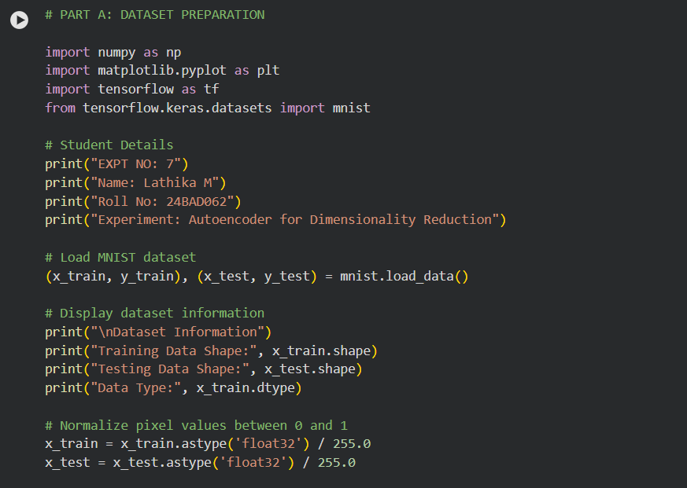

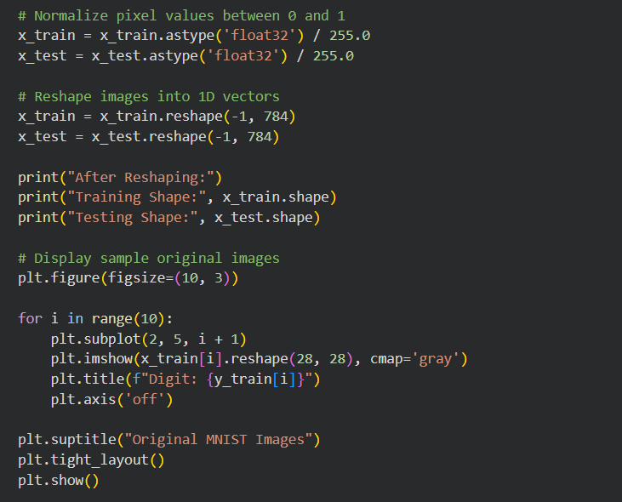

OUTPUT :

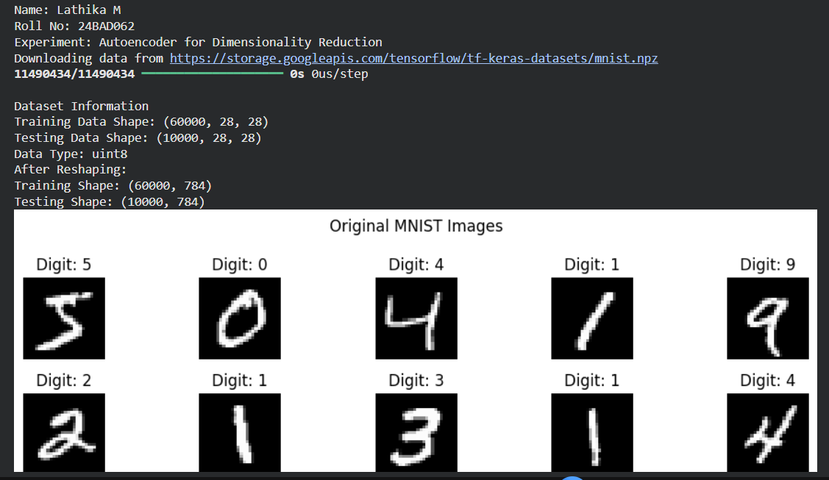

PART B: IMPLEMENTING THE AUTOENCODER MODEL
Perform the following tasks:
- Define the input layer based on the dimensions of the dataset.
- Create an Encoder using one or more Dense layers.
- Introduce a bottleneck layer with fewer neurons than the input layer to learn a compact representation.
- Create a Decoder to reconstruct the input from the bottleneck representation.
- Use a suitable activation function, such as ReLU for hidden layers and Sigmoid for normalized image reconstruction.
- Combine the Encoder and Decoder to construct the complete Autoencoder.
- Compile the model using an appropriate optimizer, such as Adam, and a reconstruction loss function, such as Mean Squared Error (MSE).
- Display the model architecture and model summary.

CODE :
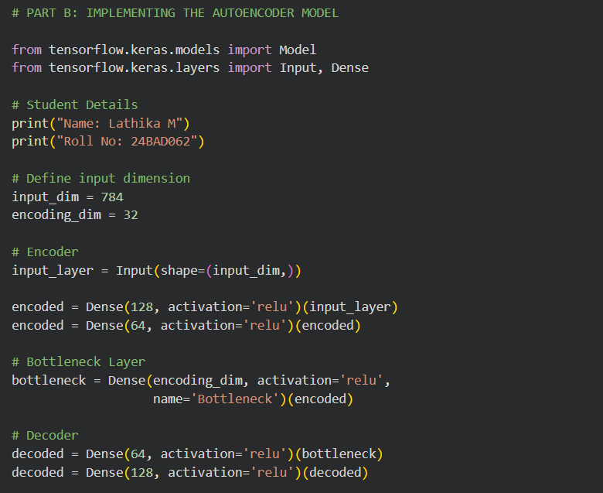

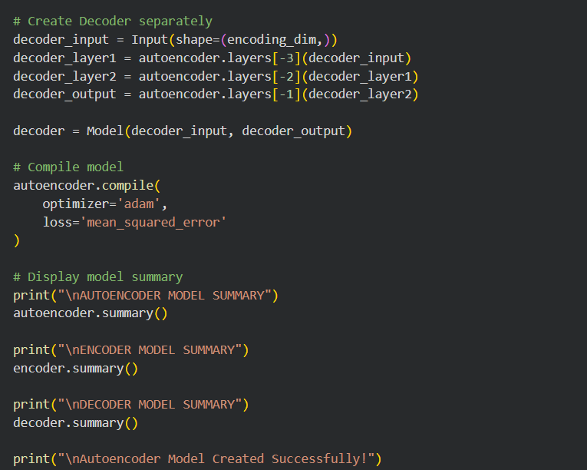

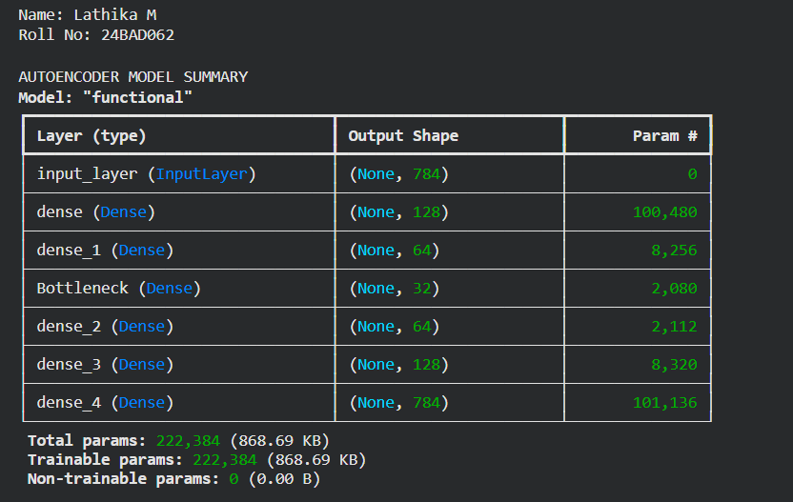

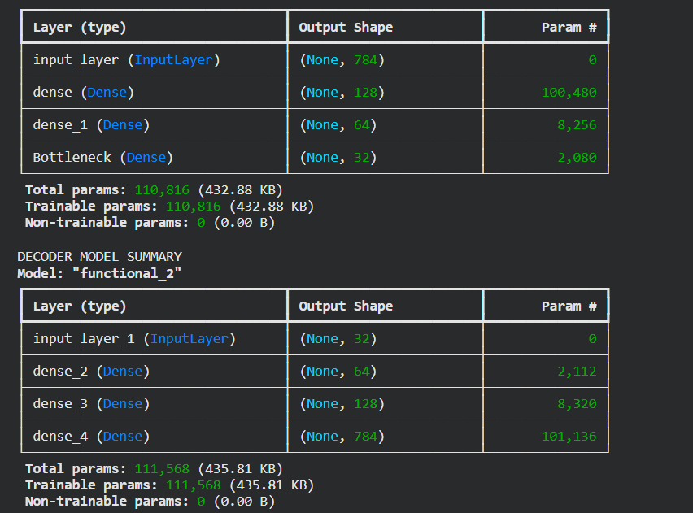

PART C: MODEL TRAINING AND PERFORMANCE EVALUATION
Perform the following tasks:
- Train the Autoencoder using the prepared training dataset.
- Use the original input samples as target outputs.
- Validate the model using validation data or the testing dataset, as appropriate.
- Record:
  - Training loss
  - Validation loss
- Evaluate the trained model using the test dataset.
- Calculate the reconstruction Mean Squared Error (MSE).
- Plot the training and validation loss against the number of epochs.
- Compare the original input images with their reconstructed outputs.

CODE :

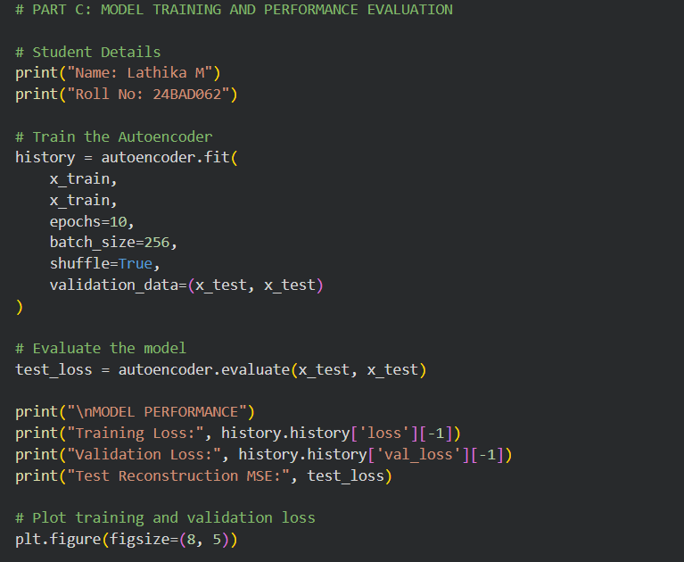

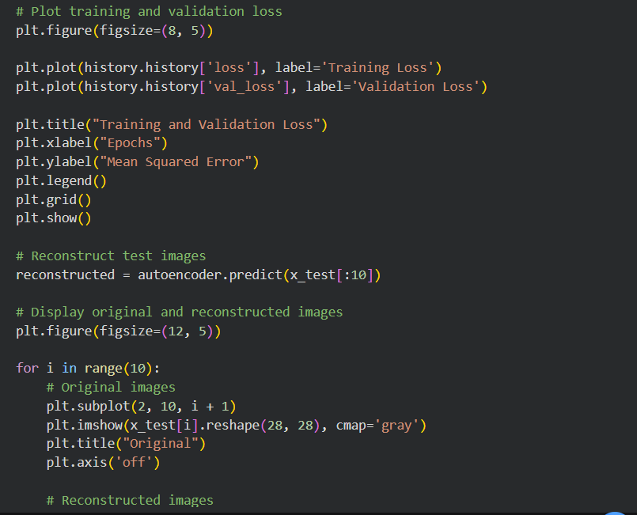

OUTPUT :

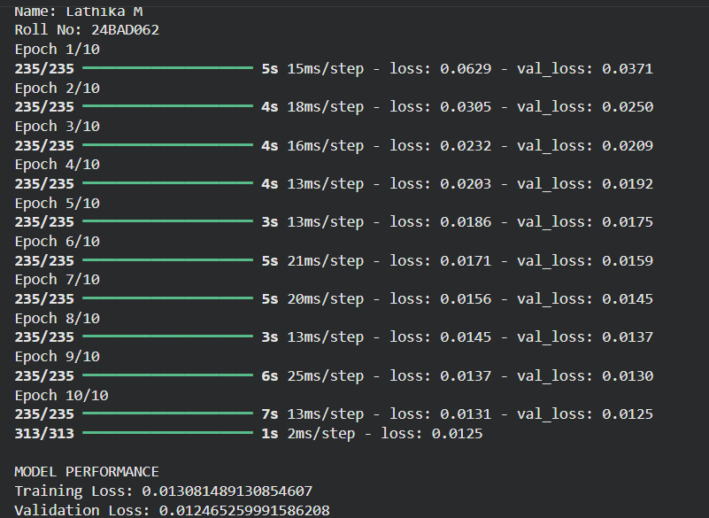

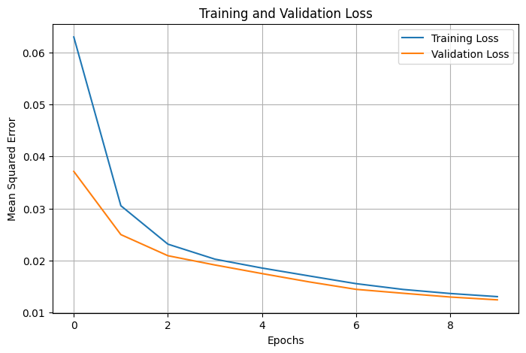

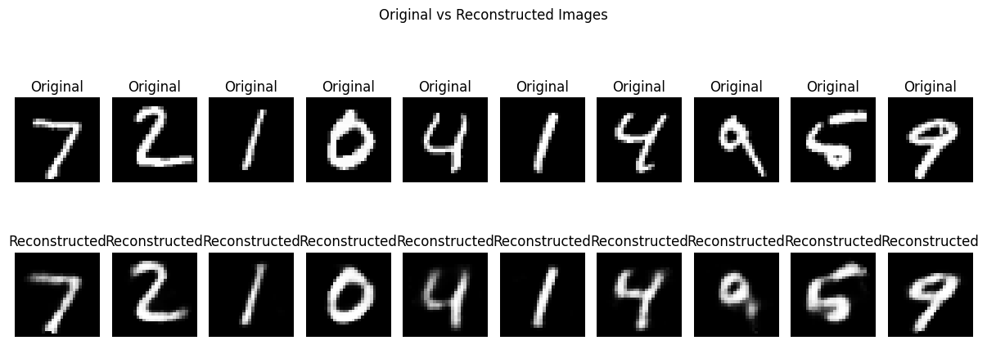

PART D: DIMENSIONALITY REDUCTION, FEATURE VISUALIZATION AND EXPERIMENT MANAGEMENT

Perform the following tasks:
- Provide new movie-review sentences as input to the trained LSTM model.
- Extract latent-space representations of test samples using the trained Encoder.
- Compare the dimensions of the original input data and compressed representations.
- Visualize the latent representations using a suitable plot.
- Reconstruct selected test samples using the Decoder and compare them with the original images.
- Record observations on dimensionality reduction and reconstruction quality.
- Document the observations and upload the notebook to GitHub.

CODE

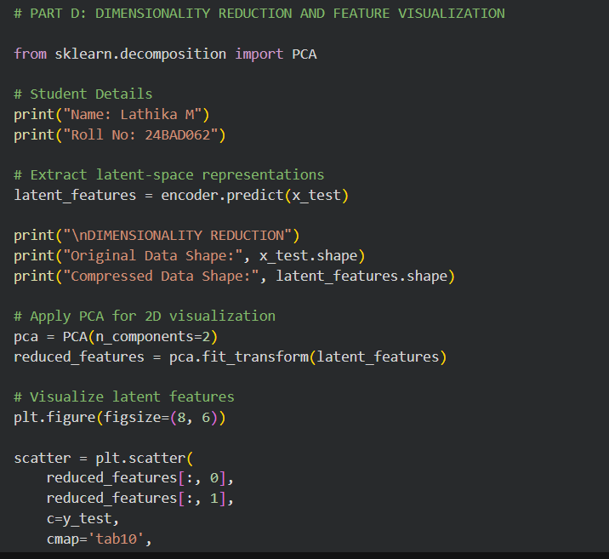

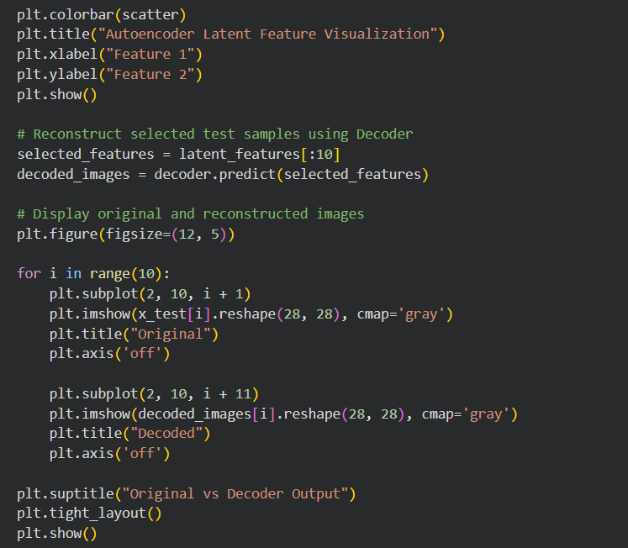

OUTPUT

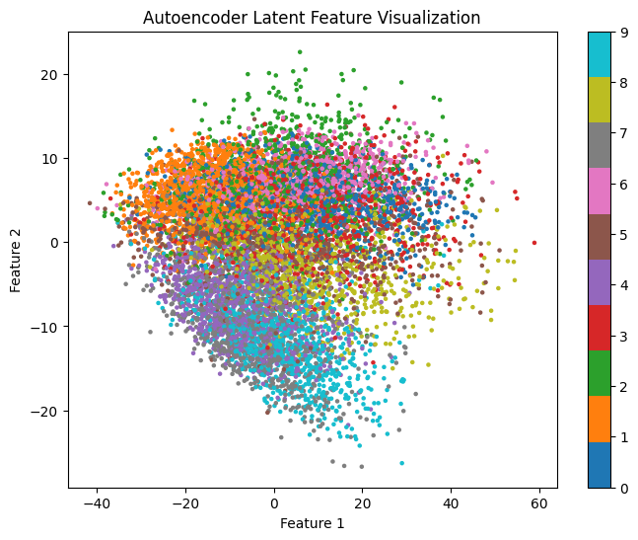

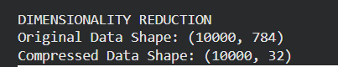

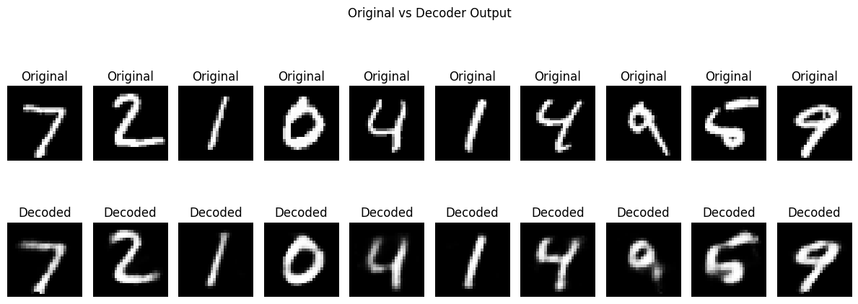

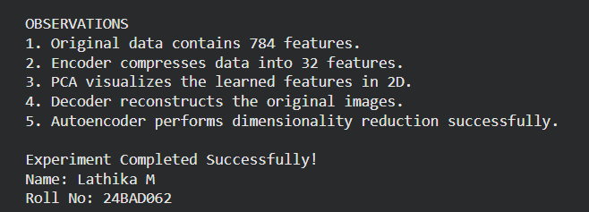

POST-LAB QUESTIONS (PROVIDE BRIEF ANSWERS TO THE FOLLOWING QUESTIONS)

1. Explain the significance of reconstruction loss in training an Autoencoder.
Reconstruction loss measures the difference between the original input data and the reconstructed output produced by the Autoencoder.

Significance:
- It measures how accurately the Autoencoder reconstructs the input.
- It helps the model identify reconstruction errors.
- It guides the model to improve its performance during training.
- Lower reconstruction loss indicates better reconstruction.
- It helps the encoder learn important features.

Example: If the original image and reconstructed image are similar, the reconstruction loss will be low.

2. State one advantage of Autoencoders over traditional dimensionality-reduction techniques.

One major advantage of Autoencoders is that they can learn complex and non-linear patterns in data.
- Traditional techniques like PCA mainly capture linear relationships.
- Autoencoders can learn both linear and non-linear features.
- They can provide better feature representations for complex datasets.
Example: Autoencoders can learn complex features from handwritten digit images.

3. Discuss two practical applications of Autoencoders apart from dimensionality reduction.

1. Anomaly Detection:
- Autoencoders are used to identify unusual patterns in data.
- They learn normal data patterns during training.
- Unusual data produces higher reconstruction error.
- They are used in fraud detection and network security.

Example: Detecting unusual bank transactions.

2. Image Denoising:

- Autoencoders are used to remove noise from images.
- The model takes a noisy image as input.
- It learns to produce a clean image as output.
- It improves image quality.

Example: Removing noise from old or damaged photographs.

ASSESSMENT
Description | Max Marks | Marks Awarded
Pre Lab Exercise | 5
In Lab Exercise | 10
Post Lab Exercise | 5
Viva | 10
Total | 30
Faculty Signature

